Winter nostalgia

In the middle of winter, secluded and sad I walk slowly in the moonlight, thoughtful looking the thick fog and the foreign horizon. A hurried traveler passed, carelessly advancing in the snowy line, in such a cold white city ruled by a terrifying silence.

The snow creaked sharply beneath my feet, caressing my fine feelings, in the oppressive light of lanterns hiding secret glances. The clock announces the midnight, the deep silence becomes suspicious, the darkness deeply hiding a forgotten vassal that suggests a mischievous expression. My body trembled with fear, cornered by the colossal appearance of the shadow. I can't run, because he caught me tightly, looking at me without any disrespect.

His gray eyes scrutinize me, a nostalgic gleam, as if embarrassed, slowly sighing, shrouded in regrets and sweet memories.

To be continued…

*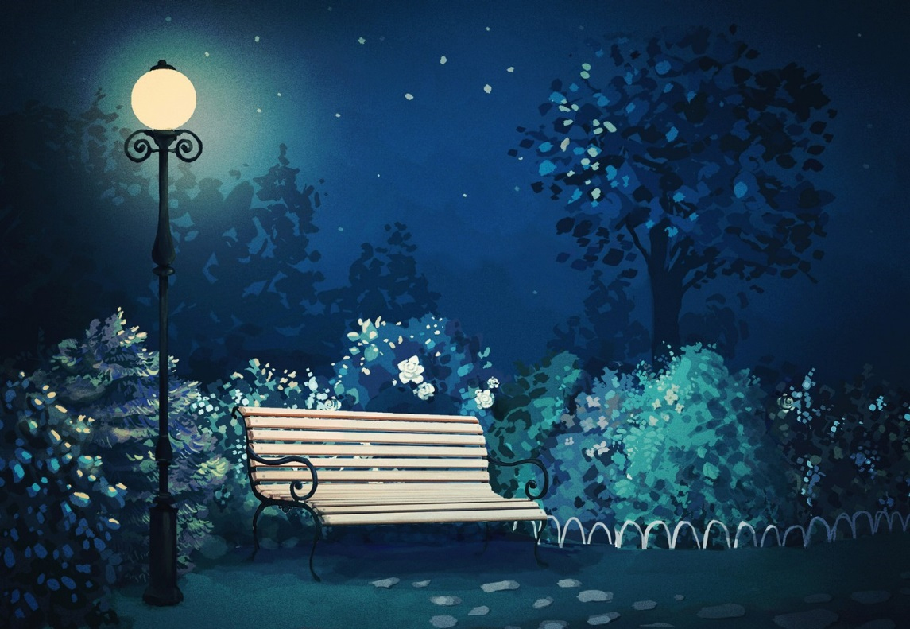Gojinevschi Ana*